**CoreLogic SQL queries**

**A.KPI’S**

**1. Total Revenue:**

SELECT SUM(total_price) AS total_revenue FROM corelogic  


**2.Average Order Value:**

SELECT SUM(total_price)/COUNT(DISTINCT customer_id) AS avg_order_value FROM corelogic



**3. Total Devices Sold:**

SELECT SUM(quantity) AS total_devices_sold FROM corelogic;



**4. Total Orders:**

SELECT COUNT(DISTINCT customer_id) AS total_orders FROM corelogic;



**5. Average Devices per Order:**

SELECT CAST(SUM(quantity)/ COUNT(DISTINCT customer_id) AS DECIMAL(10,2)) AS average_devices_per_order FROM corelogic;



**B. CHARTS:**

**1.Daily Trend for Total Orders:**

SELECT DAYNAME(purchase_date) AS day_of_the_week, COUNT(DISTINCT customer_id) AS orders_per_day FROM corelogic

GROUP BY DAYNAME(purchase_date)

ORDER BY orders_per_day DESC

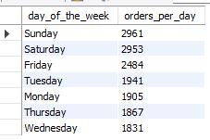

**2. Monthly Trend for Total Orders:**

SELECT MONTHNAME(purchase_date) as month_name, COUNT(DISTINCT customer_id) as orders_per_month

FROM corelogic

GROUP BY MONTHNAME(purchase_date)

ORDER BY orders_per_month DESC;

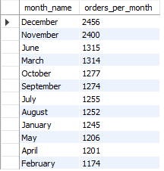

**3.Percentage of Sales by Device Type:**

SELECT product_type, SUM(total_price) AS total_sales, CAST(SUM(total_price)*100/(SELECT SUM(total_price) FROM corelogic) AS DECIMAL(10,2)) AS percentage_of_sales

FROM corelogic

GROUP BY product_type

ORDER BY percentage_of_sales DESC

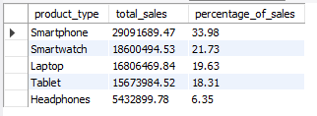

**4. Percentage of Sales by Age Range:**

WITH base AS (

SELECT

CASE

WHEN age BETWEEN 18 AND 30 THEN "18-30"

WHEN age BETWEEN 31 AND 40 THEN "31-40"

WHEN age BETWEEN 41 AND 50 THEN "41-50"

WHEN age BETWEEN 51 AND 65 THEN "51-65"

WHEN age BETWEEN 66 AND 100 THEN "66-100"

ELSE "Other"

END AS age_range,

customer_id

FROM corelogic

GROUP BY customer_id, age

)

SELECT

age_range,

COUNT(customer_id) AS orders,

ROUND(COUNT(customer_id) * 100.0 / (SELECT COUNT(*) FROM base), 2) AS percentage

FROM base

GROUP BY age_range

ORDER BY orders DESC;

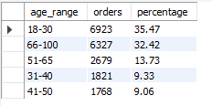

**5. Percentage of Sales by Shipping Type:**

SELECT shipping_type, SUM(total_price) AS total_sales, CAST(SUM(total_price)*100/(SELECT SUM(total_price) FROM corelogic) AS DECIMAL(10,2)) AS percentage_of_sales

FROM corelogic

GROUP BY shipping_type

ORDER BY percentage_of_sales DESC

